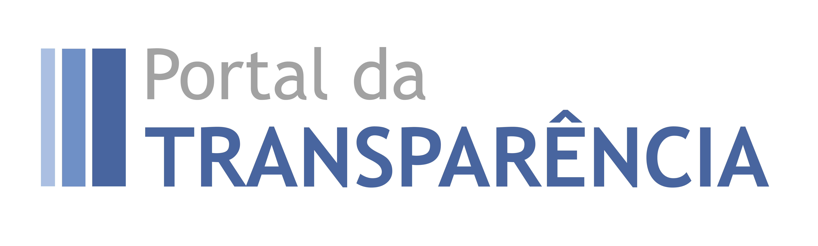

Launch of the New Portal of Transparency of the Brazilian Federal Government

Participant’s Guide

Brasília/DF - Brasil
June 28-29, 2018

Dear Participant,

It is with great joy that we welcome you for the Launch of the New Portal of Transparency of the Brazilian Federal Government.
The Portal of Transparency is an important tool developed and hosted by the Ministry of Transparency and Comptroller-General of the Union, and it is mainly used to inform society on the management of Federal Government’s resources.
This tool fosters the exercise of public oversight, providing important information so that citizens can play the role of an inspector of public resources application. Furthermore, transparency directly contributes for the betterment of public management, since it enables a broader visibility to management.
We hope you can get to know it and help us promote this great transparency initiative.
Comments and suggestions are more than welcome and can be forwarded to cgat@cgu.gov.br.

Kind regards,

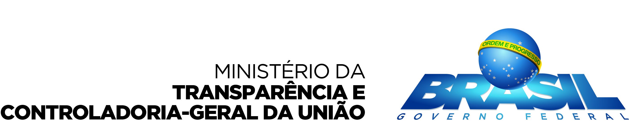

- About the Portal

The Ministry of Transparency and Comptroller General of the Union (CGU) has aimed at fostering and boosting public oversight on public policies management. In this sense, the Secretariat of Transparency and Prevention of Corruption, through its Directorate of Transparency and Public Oversight, believes that providing citizens with efficient tools to monitor public expenditures is one of the ways to strengthen citizenship.

The Portal of Transparency of the Federal Government is an initiative of the Ministry of Transparency and Comptroller-General, launched in November of 2004, in order to safeguard the good and right application of public resources. It aims at increasing transparency over public management, allowing citizens to follow how public money is being used.

The Brazilian Government trusts that transparency is the best antidote against corruption, for it is an inducing mechanism showing that public administrators act based on accountability principles and allows for society, empowered with relevant information, helps oversighting public managers and officials’ actions, with the intent of verifying whether public resources are being used the way they should.

As the institution in charge of the administration of the Portal of Transparency of the Federal Government, the CGU has carried out several betterments in the functionalities of the Portal, which, in its new version, will have search, data consolidation and expenditure tracking resources.

- What you find in the New Portal

- Federal resources transferred from the Union to states, municipalities and the Federal District for the implementation of decentralized public policies.

- Federal Government expenses on contracts of public works, services and governmental procurement for the implementation of public policies.

- Detailed and daily updated information on all expenses and revenues accrued by bodies and entities within the Federal Executive Branch.

- Allowances granted directly to citizens by means of social programs, such as the Bolsa Família program and the Program for the Eradication of Child Labor.

- Expenses made on Federal Government’s payment cards, besides other governmental corporate cards.

- Agreements signed by the Federal Government with state and municipal governments, or with nongovernmental organizations, aiming at contributing to meet local population’s needs.

- Information on administrative penalties applied to natural and legal persons and civil servants, such as the prohibition to contract with the public administration.

- Information on Federal Government’s civil and military public servants, which includes their positions and remunerations.

- List comprising the Union’s real estate assets used by public servants.

- Collection of legislation on transparency, besides links to other transparency initiatives directly implemented by governmental bodies in relation to their programs and actions.

- And so much more...

- How can the data on the Portal be used in practice?

- Identifying wrongdoings concerning the irregular payment of social allowances to citizens, such as for people who are not eligible for them.
- Avoiding new contracts with enterprises debarred from participating in public procurement or from contracting with the Public Administration due to previous wrongdoings.
- Acquiring information on public servants, such as positions and remunerations, which allows for the oversight against earnings that are higher than the constitutional limits, besides preventing nepotism and conflict of interests within the Federal Executive Branch.
- Monitoring public expenditures from the moment funds are allocated (first stage of the proceedings for public expenditure), which enables the review of undue spending before payment is made.
- Allowing for citizens to monitor money transfers to their municipalities, so that they can demand mayor’s accountability.
- Increasing the quality of data generated by the public administration, since the system provides broad transparency to budget and financial management.

- Technical Workshop

The workshop is aimed at public officials implementing fiscal transparency policies, auditing, open government and information technologies, as well as open data experts and budget civil society representatives who will use and replicate the workshop lessons and experiences. During the 1.5-day workshop, participants will:
- Learn from the Brazil’s experience in implementing its Fiscal Transparency website, including the use of technologies for the development of different interactive functionalities and techniques for effective citizen-government communication
- Learn about the coordination between government authorities and civil society organizations in the design and construction of the Brazilian portal;
- Learn about the strategies for capacity building for all stakeholders;
- Share and learn from experiences of numerous countries from Latin America and in Africa that are working on similar projects (Argentina, Colombia, Chile, Dominican Republic, El Salvador, Egypt, Guatemala, Liberia, Mexico, Nigeria, Paraguay, South Africa, and Uruguay).

- Agenda

Jun 28, 2018
Time | Session | Presenter
Morning – Fiscal Transparency Portal Launch (Main Auditory)
8:30 am | Reception and breakfast
9:00 am | Opening remarks | Minister of Planning, Secretary of Treasury, Minister of Transparency and others
9:30 am | Ministry of Transparency Speech | Ministry of Transparency, Oversight & Comptroller, Brazil
9:45 am | Overview of the New Transparency Portal | Ministry of Transparency, Brazil
10:30 am | The international View on Transparency | Remarks by the South African representatives, GIFT and OECD
11:30-11:45 am | Closing remarks
Afternoon – Fiscal Transparency Portal Workshop - Small Auditory
13:30 | Opening remarks for the Workshop | Brazil representative, IBP and GIFT
14:15 - 17:15 | Workshop on the transparency Portal: navigation with tutorship to get to know the content and tools of the Portal | Ministry of Transparency, Brazil
Afternoon - CGU
17:30 – 18:00 | Roundtable with the Minister of Transparency of Brazil
18:00 | End of day
Jun 29, 2018
Time | Session | Presenter
Morning - Workshop - Small Auditory
9:00 am | Going beyond the Portal – other elements of the transparency policy in Brazil | Ministry of Transparency, Brazil
10:30 – 12:00 | Getting technical: discussing challenges and IT solutions for transparency | Ministry of Transparency, Brazil
Afternoon - Workshop - Small Auditory
13:30 | Open opportunities: international organizations present how they are helping foster transparency | GIFT, IMF, IADB, OECD
14:00 | Budget information disclosure, open data & additional tools | Federal Budget and Planning Secretary
14:30 - 18:00 | Sharing experiences – countries (governments + CSO) share their latest projects on Transparency and | Argentina, Colombia, Chile, Dominican Republic, El Salvador, Egypt, Guatemala, Liberia, Mexico, Nigeria, Paraguay, South Africa, and Uruguay
18:00 | End of day

Notes
- Sessions will be held in English with translation to Spanish
- Other workshops will be held in parallel: journalists, civil society organizations and Brazilian subnational governments
- There will be coffee breaks along the workshop
- GIFT will offer an international dinner to internal guests on June 28

- The Venue

The launch of the New Portal of Transparency of the Brazilian Federal Government, followed by a technical workshop, will be held at Conselho Federal da Ordem dos Advogados do Brasil, localizado no Setor de Autarquias Sul (SAUS) Quadra 05, Lote 01, Bloco M – Asa Sul, Brasilia-DF, Brazil.

- Important Information

Temperature: lowest of 15º C and highest of 25^{oC}, sun with some clouds, no rain predictability. Forecast for June 28 and 29, 2018.

Transportation: from the airport, taxi and uber services work pretty well. There is also the option of getting a bus, which is called Ônibus Executivo, with an itinerary covering the way Airport-Central Area of Brasília (https://www.bsb.aero/br/antes-de-viajar/transporte/onibus-executivo/).

Hospitals: In the central area of Brasilia, some public hospitals free of charge are available such as Hospital de Base, Hospital Regional da Asa Sul and Hospital Regional da Asa Norte. For private and health insurance services, there are several options like Hospital Santa Lúcia, Hospital Santa Luzia, Hospital Home, Hospital do Coração do Brasil, Hospital Santa Helena, Hospital Brasília (Lago Sul), among others. If your trip has been sponsored by GIFT you have medical and security assistance through International SOS. If you need medical assistance please contact a GIFT staff member or call +49 6102 3588 100.

Touristic places: Torre de TV (TV Tower), Catedral (Cathedral), Esplanada dos Ministérios (Esplanade), 3ª Ponte (3rd Bridge), Museu da República (Museum of the Republic), Biblioteca Nacional (National Library), Palácio do Planalto, Palácio do Itamaraty, Palácio da Alvorada (official residence of the President), Palácio do Jaburu (oficial residence of the Vice-President), Memorial JK, Centro de Convenções Ulisses Guimarães, Parque da Cidade Sarah Kubitschek (City Park), Concha Acústica.

Must-see: Pontão do Lago Sul

Shopping Centers: Pátio Brasil, Brasília Shopping, Conjunto Nacional, Liberty Mall, ParkShopping, Iguatemi Shopping (Lago Norte), Boulevard Shopping, Pier 21 (by the lake).

Lunch: close to Conselho Federal da OAB, participants can try a great variety of self-service and à la carte restaurants at the neighborhood areas of SCLS 201, SCLS 202, SCLS 402 and SCLS 403, which are 400m to 1000m far from the venue.

Dinner: close to the Windsor, you can choose what to eat from a various restaurants and snack bars. Shopping Pátio Brasil, open from 10 am to 10 pm, has several options of restaurants, besides Churrascaria Fogo de Chão and Outback Restaurant. For an option by the Lake, you can go to Pontão do Lago Sul, or Restaurante Mangai, with a view over the 3rd Bridge. Restaurants at SCLS 402/403 are also good options.

