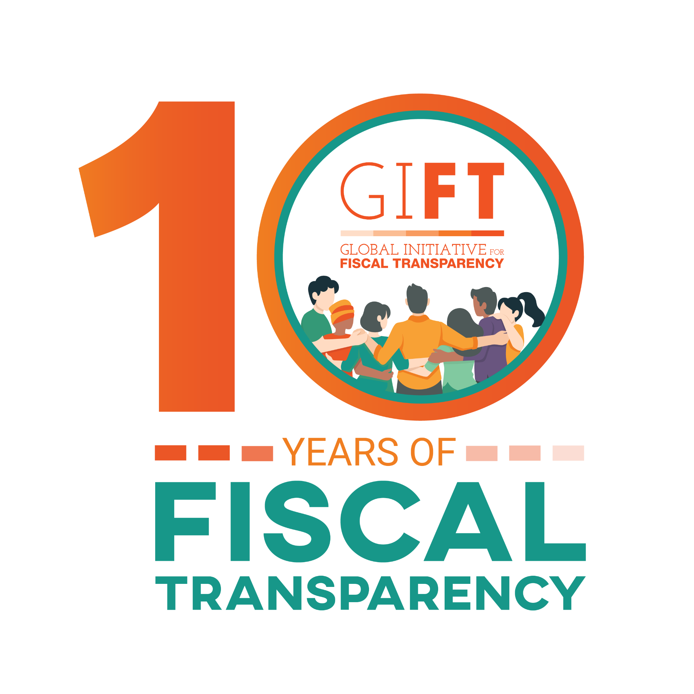
Transparency Principles for Tax Policy and Administration
Public consultation process
October 6, 2021 – January 31, 2022

Purpose roduction

In the Global Initiative for Fiscal Transparency’s (GIFT) Stewards General Meeting held in August 2021, the draft version of the Transparency Principles on Tax Policy and Principles Administration was approved for public consultation. The purpose of the public participation process is to consider diverse views and perspectives to ensure that the final version of the principles is broadly applicable and adoptable by a wide range of stakeholders, thereby strengthening their potential impact.

The principles themselves aim to serve as the basis for a comprehensive framework of norms and standards that promotes greater transparency and accountability, and encourages informed and engaged public participation in tax policy and administration. They seek to address the lack of consensus regarding what constitutes revenue transparency and how best to promote public participation in decisions regarding taxation, by identifying the information and tools needed to promote strong civic engagement in tax policy and administration.

Introduction

Taxation is at the core of the social contract between governments and the governed. Taxation not only raises the revenue that pays for government expenditures, it can also be used to influence social and economic outcomes and advance the priorities established by government. It can be a central component in achieving social justice. Sound governance requires that the governed have a voice in determining the priorities of government; understand what government seeks to achieve; and have access to the information needed to contribute to policymaking and to hold government accountable for decisions that are taken.

An accountable and transparent tax system is fundamental to good governance as it provides the basis for checks and balances and establishes the foundation for building trust in government. In recent years, consensus has emerged on a set of transparency standards that address the spending side of public budgets, however this is not the case on the revenue side. Clarity is also required on how best to promote participation and accountability pertaining to domestic taxation. The standards that do exist, are often fragmented, limited in scope, and lack support from the full-range of stakeholders affected by the outcome of fiscal policy debates. Moreover, members of the public and civil society organizations have traditionally been excluded from important taxation decisions, undermining their confidence in governments.

GIFT’s High-Level Principles on Fiscal Transparency, Participation and Accountability, adopted by United Nations General Assembly Resolution 67/218 in 2012, established norms and standards regarding the public’s right to information and participation in decisions about public spending and taxation. GIFT’s High Level Principles provide a framework for transparency in fiscal matters – both pertaining to revenue and expenditure – including the right to information on fiscal policies, the various types of fiscal information that governments should make available, and the need for independent oversight and public participation in all fiscal matters. However, the Principles do not address the issue of revenue transparency, directly and specifically. GIFT’s Principles of Public Participation in Fiscal Policy, issued in 2016, then detailed the range of decisions that should be informed by public participation and identified the points in the budget cycle and policy implementation process where governments should engage with members of the public, civil society organizations, and other non-state actors. However, these Principles too lack specificity regarding the revenue side of the budget.

A new set of global principles that establishes standards for transparency, participation, and accountability of domestic tax systems should promote an informed public and provide the basis for a strong social compact between government and the governed that helps ensure that tax systems raise needed revenues more equitably and efficiently. The adoption of such principles through a multi-stakeholder process can provide governments with clear expectations and give the public the tools needed to hold governments to account.

Background to the development of the principles

GIFT was founded in 2011 as an action network bringing together a wide array of stakeholders – spanning governments, international financial institutions, private sector representatives, and civil society organizations – to achieve sustained, measurable improvements in fiscal transparency and inclusive public participation. Through advocacy; high-level dialogue; peer-learning; technical collaboration; innovation; and research; GIFT helps to strengthen and harmonize fiscal transparency norms and standards and promote their effective implementation. GIFT facilitates dialogue among governments, civil society organizations, international financial institutions, and other stakeholders to find and share solutions to challenges in fiscal transparency and public participation with the ultimate goal of alleviating poverty and fostering inclusive and sustainable development.

In response to growing attention to the importance of taxation in international development debates, with the support of the World Bank’s Global Tax Program and in collaboration with the International Budget Partnership’s Tax Equity Initiative, GIFT commissioned a set of documents to inform the development of a comprehensive tax transparency and participation framework in 2019. This effort included publishing a compendium titled, Making Tax Work: A Framework for Enhancing Tax Transparency; a brief titled, Promoting more open and accountable tax systems: The role of international principles and standards, and a study titled, Tax Transparency and Informed Public Dialogue in Tax Policies: A civil society perspective on taxes: Scoping Study. These documents were designed to address the lack of consensus regarding what constitutes revenue transparency and how best to promote public participation in decisions regarding taxation, by identifying the information and tools needed to promote strong civic engagement in tax policy and administration. This research and accompanying dialogue informed the development of the draft principles that were discussed and approved by the GIFT Stewards at their August 2021 general meeting.

From October 2021 to January 2022, GIFT will undertake a broad consultation process on these draft tax transparency principles. This process includes making provision for online general public consultation submissions; as well as the presentation and discussion of the principles with the broader tax transparency community and in two to three countries, in order to incorporate the perspective of country-level officials and practitioners that are able to provide a more practical view of the usefulness, timeliness and scope of the exercise.
DRAFT GIFT TRANSPARENCY PRINCIPLES FOR TAX POLICY AND ADMINISTRATION

Public awareness of the role of taxation in financing more equitable and sustainable growth has increased dramatically in recent years. Domestic resource mobilization can raise revenues for poverty alleviation and reduce reliance on foreign aid and debt. Tax systems that are transparent and accountable to the public can also improve governance when taxpayers demand better services in exchange for compliance with tax laws.

Despite increased attention to the importance of taxation for sustainable development and governance, there is no consensus around the principles and practices that should guide the transparency of the information on practices of tax administration and policymaking. Global standards, such as those included as part of the OECD’s Base Erosion and Profit Shifting (BEPS) initiative, are largely focused on the exchange of information among countries and are of limited application to the full range of issues involved in domestic revenue mobilization. Other tools, such as the Tax Administration and Diagnostic Tool, Public Expenditure and Financial Accountability Framework, and International Survey on Revenue Administration are largely intended to meet the needs of government officials and financial institutions rather than those of civil society or the public. Lastly, existing standards also do not address the question of public participation in tax policy and administration decision-making.

A new set of principles, developed through an inclusive multi-stakeholder process, can serve as the basis of a comprehensive framework of norms and standards that promotes greater transparency and accountability and encourages informed and engaged public participation.

Defining tax transparency

Tax transparency can be defined as the disclosure and publication of the quantitative and qualitative data society needs about its tax system. It is a process that supplies the information required to ensure that a tax system works for the benefit of all stakeholders – in and out of government – tax administrators, other government officials, legislators, those who elected them, and those who pay taxes. The information made available through a transparent process is part of an integrated framework that includes the collection, analysis, scrutiny, dissemination, and discussion on the tax system, as well as a broader fiscal framework that includes the spending side of public budgets.

Specifically, the stakeholders of a tax system require the information that allows them to: 1) understand how the tax that people have to pay is determined; 2) understand the administrative procedures that prescribe how taxes are paid; 3) assess whether the taxes they are expected to pay are fair compared to the contribution required of others within the society of which they are a part; 4) determine whether all of those who should pay taxes actually do so; 5) evaluate what alternative options for raising revenues exist within their society; 6) understand how their tax system compares to those of similar jurisdictions; and 7) know how the taxes that are collected are used by government.

Tax transparency also enables dialogue on the design and implementation of tax policies and practices; promotes trust between government and the governed; and facilitates an understanding of the role of government in advancing social and economic goals. Accountability and transparency are two of the central pillars of good governance. A transparent and accountable tax system begins with a statement of the key goals and objectives of the tax system and a statement of what the jurisdiction’s policy and administrative frameworks are designed to achieve so that the performance of a tax system can be measured against overarching intent and purpose. Governments should regularly publish not only goals and objectives, but also the assumptions on which they are based, and the information needed to evaluate whether a tax system is working in the public interest.

Too often, however, the information on revenues that is available is incomplete, not timely, and not made public with the level of detail needed to enable informed debates. Information on critical elements of tax administration – such as audit rates and estimates of tax evasion (“tax gaps”) – is frequently limited. This lack of information on the performance of tax administrators can give rise to perceptions of a lack of fairness that, in turn, reduces compliance with tax laws. Additionally, information on what governments don’t tax – tax expenditures: the credits, deductions, and other special treatment that results in a lack of taxation – is generally less available than corresponding information on the expenditure side of the fiscal equation.

A comprehensive framework as outlined in the principles below would provide stakeholders inside and outside of government with the information needed to understand how a tax system works and would prescribe a process for ensuring that meaningful participation informs debate over policies and their implementation. To achieve these goals, GIFT offers the following principles as an elaboration on its previously adopted High-Level Principles of Fiscal Transparency, Participation, and Accountability and Principles of Public Participation in Fiscal Policy. The new principles are intended to apply to all government jurisdictions with the authority to tax and are intended to apply to all country contexts. They are designed to promote improvements in the scope, consistency, and quality of information that governments make available to the public and to establish a framework for how governments meaningfully engage with their stakeholders around issues of tax policy and administration with the ultimate goal of ensuring that public resources are used to advance the public interest.

These new principles address fundamental components of good governance and for the trust needed to ensure a more sustainable fiscal pact, namely: the right of access to information, proactive transparency, accountability, and public participation.

DRAFT TRANSPARENCY PRINCIPLES FOR TAX POLICY AND ADMINISTRATION | COMMENTS, SUGGESTIONS AND EDITS
DEFINITION OF TAX TRANSPARENCY | DEFINITION OF TAX TRANSPARENCY
Tax transparency is defined as the disclosure and publication of the quantitative and qualitative data society needs about its tax system.
It is a process that supplies the information required to ensure that a tax system works for the benefit of all stakeholders – in and out of government – tax administrators, other government officials, legislators, those who elected them, and those who pay taxes.
The information made available through a transparent process is part of an integrated framework that includes the collection, analysis, scrutiny, dissemination, and discussion on the tax system, as well as a broader fiscal framework that includes the spending side of public budgets.

PREAMBLE | PREAMBLE
The parties to these principles:

- Affirm that a meaningful system of tax transparency supplies the quantitative and qualitative data that a society needs to ensure that its tax system works for the benefit of government, for those who elected them, for those who pay taxes, and for all other stakeholders of its tax system.

- Resolve that in order to achieve this goal, all people have the fundamental right to access the information needed to assess whether a tax system is meeting its intended goals and working for the benefit of society as a whole.

- Declare that the public and all stakeholders in the tax system have a fundamental right to participate fully and effectively in public debate and discussion with respect to the design, implementation, and review of fiscal policy decisions including those decisions affecting tax policies and administration.

- Recognize that a new set of international principles to guide the development of improved and expanded norms and standards, and provide all relevant actors—including governments, the public, civil society organizations, and international institutions—with a clearer sense of what is expected of them, what they can demand and how they can support the necessary reforms, is fundamental to the development of sound domestic tax systems.

- Proclaim that a new set of international transparency principles for tax policy and administration should guide policymakers and tax administrators to ensure that:

GIFT TRANSPARENCY PRINCIPLES FOR TAX POLICY AND ADMINISTRATION | COMMENTS, SUGGESTIONS AND EDITS
THE PRINCIPLES | THE PRINCIPLES
1.All people have the fundamental right to access the information needed to assess whether a tax system meets its stated goals and works in the public interest.

2.Taxpayers should have access to clear information and advice that enables compliance with the laws of a jurisdiction, as well as the right to appeal any liabilities they believe to be incorrect.

3.Governments should publish clear and measurable goals and objectives for its tax system on a timely basis.

4.The objectives of the tax system should be supported by timely and detailed projections of future tax revenues, along with the sources of information and the assumptions underlying all estimates and projections.

5.Governments should provide the contextual information needed to place taxation within a broader fiscal, economic, and social framework.

6.Governments should publish an accounting of taxes collected at least once a year that includes a discussion of major deviations from budgeted amounts, as well as a report on whether the tax system has successfully met its stated objectives.

7.Governments should periodically evaluate and report on the extent to which taxes that are legally owed go unpaid.

8.Governments should examine the impact of and publish information on the amount, sectors and beneficiaries of tax incentives and preferences.

9.Governments should evaluate and report on the intentional and unintentional impacts or “spillover effects” of their tax system on those of other jurisdictions.

10.Tax administration should be accountable to government and to the public, and, within government, tax administrators should be accountable to the legislative branch of government.
11.All taxes and their administrative framework should be codified in law and changes in policy should be made through the legislative process.

12.The data underpinning tax transparency should be subject to verification by an independent agency that audits, evaluates, and reports on the accuracy and fairness of that data.

13.Governments should actively engage the public, civil society organizations, and other stakeholders when considering changes in tax policy or administrative procedures.

14.Where appropriate, governments should collaborate with international and regional financial institutions and tax administrators to increase revenue transparency, improve administrative practices, and conduct research on the impact of policies across countries and regions.

Additional principles for consideration should be included here.

Based on Baker, A. and Murphy, R. (2021). “Making Tax Work: A Framework for Enhancing Tax Transparency”. GIFT; these principles were drafted by Jean Ross, with the support of Raquel Ferreira and Juan Pablo Guerrero. As Network Director, Guerrero is responsible for this publication.
Baker, A. and Murphy, R. (2021). “Making Tax Work: A Framework for Enhancing Tax Transparency”. GIFT.
Guerrero, JP and P. de Renzio (2021). “Promoting more open and accountable tax systems: The Role of International principles and standards”. GIFT & IBP
Guerrero, JP. (2020). “Tax Transparency and Informed Public Dialogue in Tax Policy: A civil society perspective on taxes: Scoping study”. GIFT & IBP.
This definition is different from the OECD BEPS Initiative, where tax transparency is about putting an end to bank secrecy and tax evasion through global tax co-operation and above all, the effective exchange of information between governments and tax authorities.
Baker, A. and Murphy, R. (2021). “Making Tax Work: A Framework for Enhancing Tax Transparency”. GIFT, p. 7.
Baker, A. and Murphy, R. (2021). “Making Tax Work: A Framework for Enhancing Tax Transparency”. GIFT, pp.3- 4.
Baker, A. and Murphy, R. (2021). “Making Tax Work: A Framework for Enhancing Tax Transparency”. GIFT, pp. 12-13.

