**Strengthening budget transparency and participation**

A twinning programme between the Governments of Benin and Madagascar

# Introduction

The national budget is a political statement made by governments about their development priorities. The existence of effective transparency and participation mechanisms is critical to ensure that governments fulfil their obligations and promises. To achieve better accountability, accountability stakeholders must have access to budget information to fulfil their roles in the accountability ecosystem. Through better accountability of the budgetary process helps countries have: 1) better macro-fiscal outcomes; 2) better governance and less corruption; 3) more legitimate budgets and resource allocation; and 4) better service delivery. Scholars, budget practitioners, and development partners have posited: How and when does transparency lead to greater accountability?

CABRI is an intergovernmental organisation that has gained a track record in supporting the strengthening national processes and practices to improve budget transparency. CABRI supports budget offices by facilitating discussions and peer exchanges; and providing context-specific guidance to develop and implement sustainable reforms. In the past, we have undertaken joint country case studies with the [DRC](http://www.cabri-sbo.org/en/publications/fiscal-transparency-and-participation-in-the-democratic-republic-of-the-congo-current-status-and-priorities-for-reform-1), [Kenya](http://www.cabri-sbo.org/en/publications/fiscal-transparency-and-participation-in-kenya-current-status-and-priorities-for-reform), and [Tunisia](http://www.cabri-sbo.org/en/publications/fiscal-transparency-and-participation-in-post-revolution-tunisia-current-status-and-priorities-for-reform). The DRC and Tunisia were among the group of African countries that achieved the most impressive improvements in the 2015 Open Budget Index. This country-led processes allows budget offices to implement plans/reforms that use existing practices and frameworks to make strides in budget transparency. While using existing practices and frameworks, CABRI taps other African countries to share how they have made quick, tangible gains in budget transparency in a short amount of time. In addition to sharing peer country experiences, CABRI leverages other partners, including civil society and other stakeholders, to help governments improve on indicators like the Open Budget Index.

In addition to strengthening national processes and practices to improve budget transparency, improving participation is imperative to improving accountability on the continent. CARBI is a lead steward of the Global Initiative for Fiscal Transparency. [GIFT’s Public Participation Principles Guide](http://guide.fiscaltransparency.net/) provide governments guidance about how to integrate public participation into fiscal policy and the associated benefits. This project can help answer: *How Can Ministries of Finance Provide Spaces for Participation to Help Close the Gap between Transparency and Accountability?*

CABRI would like to invite the Ministry of Economy, Finance and Decentralisation Programmes (MEFDP) of Benin and the Ministry of Finance and Budget (MEFB) to participate in a twinning programme, which aims to support improvements in budget transparency and participation of key actors over a one-year period. The programme also aims to build a peer alliance, whereby the two countries may work together beyond the duration of the programme. Both countries will undertake a journey of reflection, learning and action. Each peer will act as a sounding board, share experiences, provide perspectives and test ideas. Involvement in the programme will require **strong commitment** from the Ministry of Finance, in terms of, political will, time and resources to improve transparency and participation. The programme is open to CABRI member countries. Benin will need to have initiate the process to become members prior to the framing workshop.

This concept note presents a summary of budget transparency in Benin and Madagascar; the objectives of the twinning exercise; and, the proposed approach. The work plan for the twinning programme will be developed at the framing workshop.

# Budget transparency and participation in Benin and Madagascar

The Governments of Benin and Madagascar have both made some progress in producing and publishing information related to their national budget. While consolidating those gains, both finance ministries have internalised the importance of effectively engaging citizens and their representatives on budgetary matters.

## Benin

Benin’s improvements, in the availability of budget documentation, are clearly visible using CABRI’s Budget Enquirer. In 2013, Benin made the pre-budget statement, the Executive’s budget statement, the in-year report and the mid-review review publicly available and produced a Citizen’s Budget. In 2014, most of these documents were accessible online. As of 2016, Benin publishes all documents except for the audit report.

Table 1: Online availability of budget documents in Benin

|  |  |  |  |  |  |  |
| --- | --- | --- | --- | --- | --- | --- |
| **BENIN** | | | | | | |
| **Document** | **2011** | **2012** | **2013** | **2014** | **2015** | **2016** |
| Pre-budget statement |  |  |  |  | ▪ | ▪ |
| Executive's budget statement |  |  | ▪ | ▪ | ▪ | ▪ |
| Enacted budget |  |  | ▪ |  | ▪ | ▪ |
| Citizens' budget |  | ▪ |  | ▪ | ▪ | ▪ |
| In-year reports |  |  |  | ▪ | ▪ | ▪ |
| Mid-year review |  |  |  | ▪ |  |  |
| Year-end report |  |  |  | ▪ | ▪ |  |
| Audit report | ▪ | ▪ | ▪ | ▪ |  |  |

Source: CABRI February 2017

**Legend**

|  |  |
| --- | --- |
|  | Available online |
|  | Produced for free public access, but not available online |
|  | Produced for paid public access, at a set fee |
|  | Produced for internal use only |
|  | Not produced |

According to the 2015 Open Budget Survey (OBS), the Government of Benin scores 45 points out of 100, providing the public with limited budget information. In addition to measuring the number and type of budget documents that are made publically available; the survey also assesses the comprehensiveness of these documents. Figure one below suggests that the enacted budget and in-year reports contain substantial information, whereas significant improvements can be made to the pre-budget statement, the Executive’s budget proposal and the mid-year review.

Figure 1: Usefulness of budget information

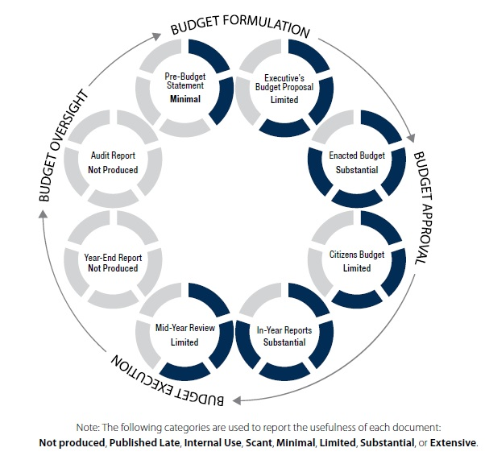

Source: IBP OBS 2015

Benin has set up a transparency and communication unit to actively involve civil society organisations and the media in the budgetary process (see [CABRI blog on reflections on budget transparency in francophone country](http://www.cabri-sbo.org/en/blog/2016/reflections-on-budget-transparency-in-francophone-africa)).

IBP recently published the December 2016 update of the Open Budget Survey Document Availability Tracker. Comparing the publication status of documents between the OBS 2015 and the recent update, Benin is making strikes in publishing timely budget documents.

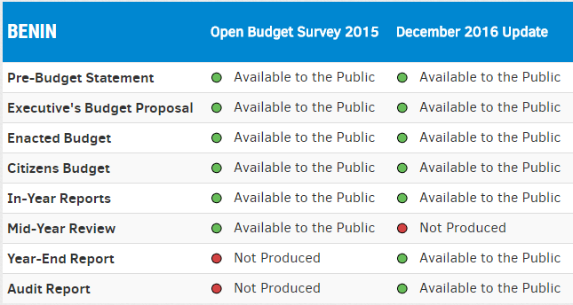

Source: IBP

IBP’s Open Budget Survey includes questions to measure budget participation. Per the IBP, budget participation is measured as “the opportunities governments are providing to civil society and the general public to engage in decisions about how public resources are raised and spent.”[1] These questions measure participation throughout the budget cycle. According the Open Budget Survey 2015, the executive branch (Ministry of Finance in particular) provides weak opportunities for the public to be involved in the formulation and execution stage of the budget.



Source: IBP

## Madagascar

According to CABRI’s budget enquirer, the Government of Madagascar produces 7 of the 8 budget documents regarded as good practice in the OBS. Of the seven documents, the in-year reports, the year-end report and the audit report are produced for free public access, but not available online and the pre-budget statement is only produced for internal use. Per the International Budget Partnership’s Open Budget Survey Document Tracker, the in-year reports are published online while the citizen’s budget and audit report were published late The Government of Madagascar does not produce a mid-year review.

Table 2: Online availability of budget documents in Madagascar

|  |  |  |  |  |  |  |
| --- | --- | --- | --- | --- | --- | --- |
| **MADAGASCAR** | | | | | | |
| **Document** | **2011** | **2012** | **2013** | **2014** | **2015** | **2016** |
| Pre-budget statement |  |  |  |  |  |  |
| Executive's budget statement |  |  |  | ▪ | ▪ |  |
| Enacted budget | ▪ | ▪ | ▪ | ▪ | ▪ | ▪ |
| Citizens' budget |  |  |  |  |  |  |
| In-year reports |  |  |  | ▪ | ▪ | ▪ |
| Mid-year review |  |  |  |  |  |  |
| Year-end report |  |  |  |  |  |  |
| Audit report |  |  |  |  |  |  |

Source: CABRI February 2017

**Legend**

|  |  |
| --- | --- |
|  | Available online |
|  | Produced for free public access, but not available online |
|  | Produced for paid public access, at a set fee |
|  | Produced for internal use only |
|  | Not produced |

Madagascar will be included in the Open Budget Survey 2017 for the first time, which will provide us with a comparable assessment of the comprehensiveness of publicly available budget information and opportunities for public participation. Per IBP’s latest assessment on publication of documents, the pre-budget statement, citizens budget, and the audit report were published late. Madagascar currently produces 7 of the 8 key budget documents.

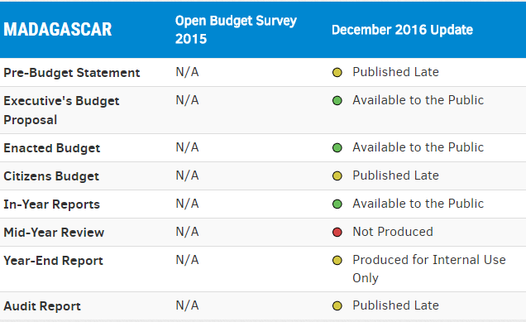

Source: IBP

# Objective of the exercise

Both ministries have highlighted a real willingness to strengthen the link between transparency and participation to have better accountability. Through greater transparency, the government will be able to communicate its plans and ambitions to CSOs, media, parliamentarians, and the general public. Similarly, by enhancing participation, the Governments will be able to promote a more inclusive budgetary process towards greater accountability. CABRI aims to strengthen the capabilities of the Ministries to deliver on those objectives that will be measured through improvements on the OBS.

In achieving this outcome, the programme will look to at the following components:

|  |  |  |
| --- | --- | --- |
| **Information** | **Audience** | **Engagement** |
| What information?  When?  To whom?  What form?  Process to develop information | Which actors?  What are their needs?  How are actors determined? | For what purpose?  How?  By whom?  When?  Process |

By looking at the processes and practices on producing and publishing budget documents and providing spaces for participation, Benin and Madagascar can make great strides in improving budget transparency and participation. CABRI documented Benin’s improvement on budget transparency in [Reflections on budget transparency in Francophone Africa](http://www.cabri-sbo.org/en/blog/2016/reflections-on-budget-transparency-in-francophone-africa). While Madagascar’s Open Budget Index 2017 score is unknown yet, the country publishes several volumes comprise the Executive’s Budget Proposal and publishes quarterly in-year reports that include performance indicators for each MDA. This indicates that the country will probably score well above 30 points on the Index. This would still mean that both countries provide only limited amounts of budget information to the public (scoring between 41 and 60 on the OBI). Participation of citizens and organized civil society is limited as well.

Currently, IBP is concluding the research process for the Open Budget Survey 2017. Per IBP’s methodology, the budget documents that are assessed in the 2017 edition are those that are publicly available on or before 31 December 2016. IBP provides an opportunity for governments to review and comment on the draft Open Budget Questionnaire 2017. While providing comments on the draft Open Budget Questionnaire may not improve both countries score, it is a valuable exercise to understand the potential recommendations on behalf of IBP. IBP plans on publishing the Open Budget Survey 2017 at the end of 2017. IBP charted a path for countries to boost their OBI scores and begin to publish sufficient amounts of budget information to allow for informed public debate.[2] Benin and Madagascar could strive to achieve adequate levels of transparency by scoring 61 or above in the Open Budget Index 2019. Similarly, both countries can strive to improve their public participation scores in the Open Budget Survey 2019.

**Expected outcomes:** Upon implementation, the project will result in improvements of the OBI and public participation scores in the 2019 Open Budget Survey.

# Our approach

Benin and Madagascar are committed to improving budget transparency and participation, are at similar stages of reform and have both requested support from CABRI. Whilst, their country contexts are somewhat different, CABRI believes that a twinning programme between the two ministries will foster dialogue, learning and support for tackling pressing challenges. Both countries are keen to develop mechanisms that allow for greater participation in the budget process. The twinning programme will provide a space for reflection and ideas over a one-year period. The programme will assist to form an alliance between officials within the ministries of finance in Benin and Madagascar, in an open, frank and trusting environment.

## The twinning team

The programme will include a core team of four to five officials from each country, drawn mainly from the finance ministry. The team will propose additional in-country actors, as the exercise progresses. This exercise will be led by each ministry and their authoriser (i.e. the Minister) to be fully successful. The CABRI Secretariat will support the process by providing the overall coordination of the exercise and technical guidance to the process.

## The programme

The programme comprises four stages, as follows.

### Framing workshop

The framing workshop will bring together the twinning team. Here, CABRI will present its understanding of budget transparency and participation. Officials from Benin and Madagascar will present their country contexts, their efforts in promoting transparency and participation and some of the challenges they are facing. Through a guided discussion Both countries have implemented reforms to improve transparency. The second day of the workshop will be spent mapping the accountability ecosystem, defining what accessibility and participation means in each context and provide countries with examples of participation throughout the budget cycle. The third half day of the workshop is to frame the project and agree on the scope and work plan. See proposed programme in Annex I.

### In-country workshops

The in-country workshop will guide officials to identify three critical problems or challenges, deconstruct them and to work together to develop feasible context-specific actions and timeframes to address them. Cross-sectional working groups maybe identified to implement the actions. A workshop will be held in both Benin and Madagascar. Each workshop will be comprised of the MoF officials, parliamentarians, supreme audit institutions, and civil society. The draft programmes for each individual workshop will be one of the key outputs after the framework workshop. CABRI will assist the MoF officials in developing the programme for each in-country workshop.

### Action Push Period

The teams will then return to their countries and work together over a period of one year, engaging in three week iterations. Each iteration involves an action ‘push’ in which the two country teams act on the specific next steps they identify, reflect on the experience of such actions, and determine the next steps for the subsequent month.

#### Update session

The country teams will, additionally, produce simple update documents indicating *what was done, what was learned, and what is next*. These documents will form the basis of skype-based coaching sessions by CABRI facilitators, which will take place every month. There are several meetings/workshops until the final quarter of the year that can replace the monthly update session. The facilitators will focus on modelling the importance of small-step-accountability in the process of getting things done, and helping to ensure lessons are learned, and pressing teams to build real momentum into their next steps.

The twinning team will come together at least every two months, where the update session would be done in person.

#### Engaging authorisers

Every update session will be followed by a memo the teams produce for their authorisers in-country (ministers and bureaucratic heads). The CABRI facilitators will produce a monthly report to these authorisers as well (and to their funders) to report on progress, and every month the CABRI facilitator will engage with an authoriser to check-in on the team performance.

#### Reflection memo

At the end of this *action push period* (one year), each country team will produce a reflection memo on their experience which will be reviewed by their twin.

### GIFT/CABRI Participation and Open Data workshop

To further strengthen the relationship between transparency and participation to have better accountability, CABRI will collaborate with GIFT as a part of the Fiscal Openness Working Group to bring together African OGP and non-OGP countries and civil society to discuss participation and open data on the continent. This would be a good opportunity for both Benin and Madagascar to showcase the efforts they have undertaken on transparency and participation. These countries can also receive feedback and suggestions from other peer countries. By this workshop CABRI will have identified a consultant to be able to present research on *How Can Ministries of Finance Provide Spaces for Participation to Help Close the Gap between Transparency and Accountability?* The consultant will use this space to receive feedback and suggestions for publication in the first quarter of 2018.

The proposed timeframe for the programme is set out in Annex II.

# Annex I: Proposed Programme

|  |  |  |
| --- | --- | --- |
| Governments in Africa are increasingly improving on budget transparency. Transparency alone is not enough to achieve accountability. How and when does transparency lead to greater accountability? Participation is a key component to having better accountability. This workshop will examine the relationship between transparency and participation to achieve better accountability in Benin and Madagascar. Both countries will present their gains in budget transparency and participation and the challenges in promoting transparency and participation. This workshop will focus on mapping the stakeholders in the accountability ecosystem, identify how MoFs can enable participation in the budget process, and layout the workplan for the upcoming year.  **Day 1 – Monday 5th June** | | |
| **Start** | **End** | **Activities** |
| 8:00 | 8:30 | **REGISTRATION AND COFFEE** |
| 9:00 | 9:30 | **Welcome and introductions**   * Introductory remarks by Neil Cole (CABRI) * Round of introductions * Presentation of CABRI’s focus on transparency, accountability, and participation |
| 9:30 | 11:00 | **Presentation on Benin**  **Objective:** Gain a better understanding of the transparency and participation context in Benin.  Presentation developed by the team from Benin will cover aspect such as:   * Political economy * PFM reforms * Legal framework around transparency and participation throughout the budget cycle * Strategic priorities * Transparency and Communication Unit: mandate, structure, roles and responsibilities, resources and capability * Authorising framework   Discussions |
| 11:00 | 11:30 | Tea and Coffee Break |
| 11:30 | 13:00 | **Presentation on Madagascar**  **Objective:** Gain a better understanding of the transparency and participation context in Madagascar  Presentation by the team from Madagascar will cover aspect such as:   * Political economy * PFM reforms * Legal framework around transparency and participation throughout the budget cycle * Strategic priorities * Existing transparency and communication mechanisms * Authorising framework   Discussions |
| 13:00 | 14:00 | Lunch Break |
| 14:00 | 16:30 | **The challenges around transparency and participation**  **Objective:** This session will focus on understanding the pressing challenges faced by Ministry of Finance officials in Benin and Madagascar in strengthening transparency and participation in their respective countries.  Facilitator: Joana Bento (CABRI)  *Break for tea and coffee at 15:00 - 15:30* |
|  |  |  |
| **Day 2 - Wednesday 6th June**  **Start End Activities** | | |
| 8:30 | 9:00 | **Coffee** |
| 9:00 | 12:30 | **Mapping Stakeholders and the Budget Informational Flow**  **Objective:** Representatives of each country will discuss and map the relevant stakeholders in accountability ecosystem in their country. It also entails discussing the flow of budgetary information in the public finance management system including the what type of information is required from whom and at what period.  Facilitator: Michael Castro (CABRI)  *Break for tea and coffee at 10:30 - 11:00* |
| 12:30 | 13:30 | **Lunch** |
| 13:30 | 17:00 | **Accessibility and Participation: *How Can Ministries of Finance Provide Spaces for Participation to Help Close the Gap between Transparency and Accountability?***  **Objective:** Budgets are meant to communicate the government’s policy intentions. At times, the language in budget documents could only be understood by experts. How can governments lay the groundwork to make budget documents more accessible to the broader public? By the end of the session, participants will be able to understand how best to present information in different formats including Citizen’s Budgets. Additionally, participants will better understand how other government institutions implemented mechanisms promoting participation throughout the budget cycle.  Facilitator: Michael Castro (CABRI)  *Break for tea and coffee at 15:00 - 15:30* |

|  |  |  |
| --- | --- | --- |
| **Day 3 - Wednesday 7th June**  **Start End Activities** | | |
| 8:30 | 9:00 | **Coffee** |
| 9:00 | 12:30 | **Framing the twinning project**  **Objective:** Define the scope and activities to be undertaken under this project. This will include:   * Expectations from the different sides * Defining activities * Measuring success * Commitment to the iterative approach * Agree on timeline (including discussion every 3 weeks, regular follow up and in-country visits and activities)   Facilitator: Michael Castro (CABRI)  *Break for tea and coffee at 10:30 - 11:00* |

# Annex II: Proposed Schedule of Activities

|  |  |  |
| --- | --- | --- |
| **Activity** | **Audience** | **Date and Location** |
| Framing workshop | Twinning Team | 5-7 June 2017  Pretoria, South Africa |
| Workshop on strengthening budget Transparency and participation in Benin | Budget Office  Accountant-General  Other relevant departments and directorates linked to transparency and participation.  OGP coordinating team  Selected CSOs, Media and parliamentarians  Peers: Madagascar | July  Cotonou, Benin |
| Workshop on Strengthening Budget Transparency and Strengthening in Madagascar | Budget Office  Accountant-General; other relevant departments and directorates linked to transparency and participation.  Selected CSOs and parliamentarians  Peers: Benin | October  Antananarivo, Madagascar |
| Action Push –  Face to face progress meetings  Skype calls will take place every 3 weeks | Twinning Team | August 2017  December 2017  January 2018 |
| GIFT/CABRI Participation and Open Data workshop |  | November 2017 |

1. <http://www.internationalbudget.org/opening-budgets/open-budget-initiative/open-budget-survey/>
2. [The Road to 61: Achieving Sufficient Levels of Budget Transparency](http://www.internationalbudget.org/publications/achieving-sufficient-levels-budget-transparency/)